M3, Simple Linear Regression Model

Responsive Variable: Diammonium Phosphate

Explanatory Variable: U.S consumer price index CPI

**Load data into Rstudio**

> library(readxl)

> DAP_vs_CPI <- read_excel("Documents/3-Time Series Analysis:Forecasting:Regression-Diammonium Phosphate CPI:/DAP vs CPI.xlsx")

**Assign variables into different vector**

> View(DAP_vs_CPI)

> date <- DAP_vs_CPI$...1

> DAP <- DAP_vs_CPI$`Diammonium phosphate, US Gulf NOLA DAP Export Spot Price per MT, USD/metric tonne`

> CPI <- DAP_vs_CPI$USACPIALLMINMEI

**Create dataframe and format it into a time series form**

df1 <- data.frame(date, DAP, CPI)

> head(df1)

date DAP CPI

1 1980-01-01 261.3158 32.82465

2 1980-02-01 258.0952 33.28875

3 1980-03-01 259.8571 33.79504

4 1980-04-01 248.0909 34.17476

5 1980-05-01 211.3636 34.51229

6 1980-06-01 214.2381 34.89201

**Plot multiple time series data**

library(tidyr)

> library(dplyr)

The following objects are masked from ‘package:stats’:

filter, lag

The following objects are masked from ‘package:base’:

intersect, setdiff, setequal, union

> df2 <- df1 %>%

+ select(date, DAP, CPI) %>%

+ gather(key = "variable", value = "value", -date)

> head(df2)

date variable value

1 1980-01-01 DAP 261.3158

2 1980-02-01 DAP 258.0952

3 1980-03-01 DAP 259.8571

4 1980-04-01 DAP 248.0909

5 1980-05-01 DAP 211.3636

6 1980-06-01 DAP 214.2381

> ggplot(df2, aes(x = date, y = value))+

+ geom_line(aes(color = variable), size = 1) +

+ scale_color_manual(values = c("#E7B800","#00AFBB")) +

+ theme_minimal()

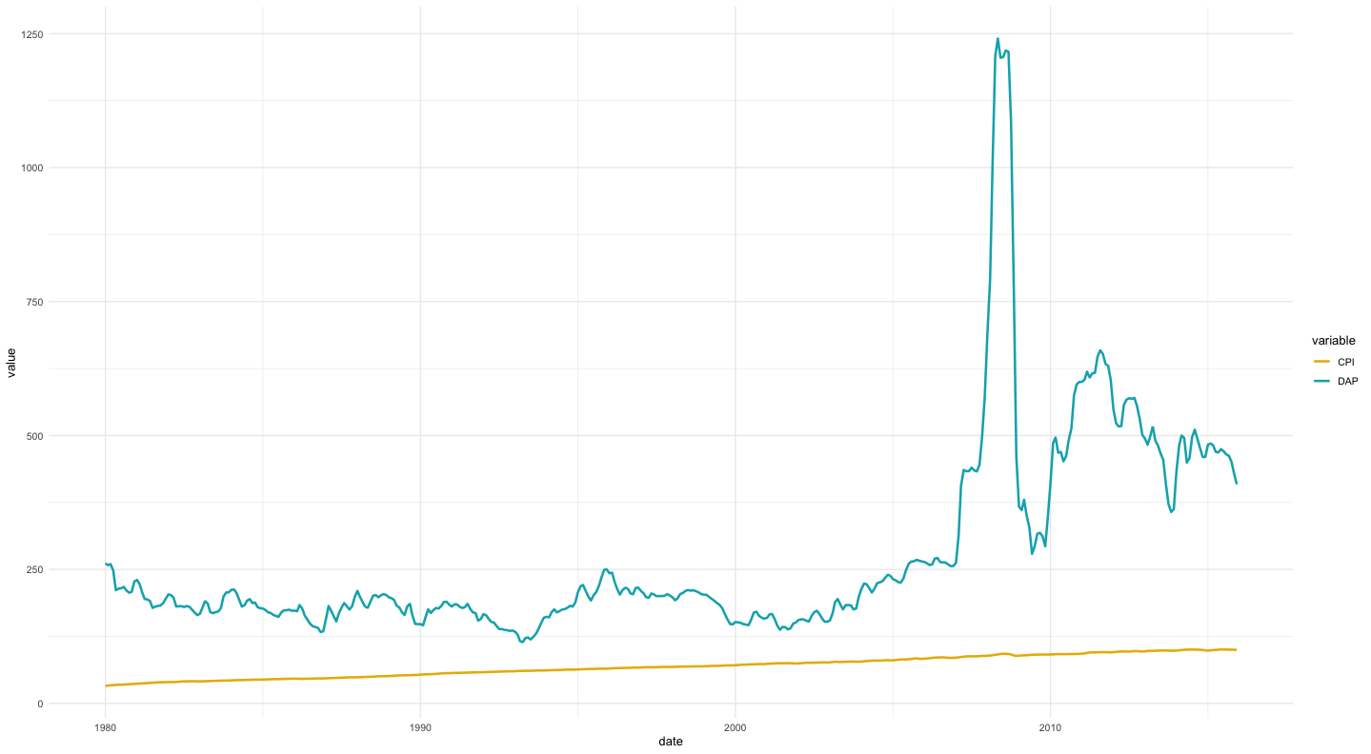

**Fit a linear model using tslm function for times series data format**

> library(forecast)

> df1_ts <- ts(df1[,2,3], start = c(1980,01), frequency = 12)

> head(df1_ts)

Jan Feb Mar Apr May Jun

1980 261.3158 258.0952 259.8571 248.0909 211.3636 214.2381

> model_lm_ts <- tslm(DAP ~ CPI, data = df1_ts)

> summary(model_lm_ts)

Call:

tslm(formula = DAP ~ CPI, data = df1_ts)

Residuals:

Min 1Q Median 3Q Max

-175.86 -91.34 -16.30 51.73 829.26

Coefficients:

Estimate Std. Error t value Pr(>|t|)

(Intercept) -140.1457 25.0930 -5.585 4.15e-08 ***

CPI 6.0352 0.3514 17.176 < 2e-16 ***

---

Signif. codes: 0 ‘***’ 0.001 ‘**’ 0.01 ‘*’ 0.05 ‘.’ 0.1 ‘ ’ 1

Residual standard error: 142.8 on 430 degrees of freedom

Multiple R-squared: 0.4069, Adjusted R-squared: 0.4055

F-statistic: 295 on 1 and 430 DF, p-value: < 2.2e-16

**The result is statistically significant since the p value for CPI and intercept are both smaller than 0.05. However, the R-squared is 0.4069, which indicate a bad fit**

> forecast(df1_ts, h=60)

Point Forecast Lo 80 Hi 80 Lo 95 Hi 95

Jan 2016 402.2803 372.437032 432.1235 356.638971 447.9216

Feb 2016 396.9730 351.360802 442.5851 327.215179 466.7308

Mar 2016 392.7271 333.230067 452.2242 301.734230 483.7200

Apr 2016 389.3304 316.986001 461.6749 278.689169 499.9717

May 2016 386.6131 302.191064 471.0351 257.500742 515.7254

Jun 2016 384.4392 288.583784 480.2946 237.840984 531.0374

Jul 2016 382.7001 275.977135 489.4231 219.481404 545.9188

Aug 2016 381.3088 264.224984 498.3927 202.244540 560.3731

Sep 2016 380.1958 253.208073 507.1835 185.984830 574.4068

Oct 2016 379.3054 242.826945 515.7838 170.579625 588.0311

Nov 2016 378.5930 232.997711 524.1884 155.924198 601.2619

Dec 2016 378.0232 223.649180 532.3972 141.928525 614.1178

Jan 2017 377.5673 214.720710 540.4138 128.514944 626.6196

Feb 2017 377.2026 206.160508 548.2446 115.616314 638.7888

Mar 2017 376.9108 197.924249 555.8973 103.174500 650.6471

Apr 2017 376.6774 189.973921 563.3808 91.139088 662.2156

May 2017 376.4906 182.276857 570.7044 79.466295 673.5150

Jun 2017 376.3412 174.804918 577.8776 68.118032 684.5645

Jul 2017 376.2217 167.533807 584.9097 57.061092 695.3824

Aug 2017 376.1261 160.442486 591.8098 46.266465 705.9858

Sep 2017 376.0496 153.512686 598.5866 35.708740 716.3905

Oct 2017 375.9884 146.728491 605.2484 25.365601 726.6113

Nov 2017 375.9395 140.075990 611.8030 15.217392 736.6616

Dec 2017 375.9003 133.542980 618.2577 5.246746 746.5539

Jan 2018 375.8690 127.118718 624.6193 -4.561730 756.2997

Feb 2018 375.8439 120.793710 630.8942 -14.221727 765.9096

Mar 2018 375.8239 114.559537 637.0882 -23.745458 775.3932

Apr 2018 375.8079 108.408699 643.2070 -33.143862 784.7596

May 2018 375.7950 102.334492 649.2555 -42.426767 794.0168

Jun 2018 375.7848 96.330901 655.2386 -51.603032 803.1725

Jul 2018 375.7765 90.392508 661.1606 -60.680672 812.2338

Aug 2018 375.7700 84.514413 667.0255 -69.666965 821.2069

Sep 2018 375.7647 78.692171 672.8373 -78.568534 830.0980

Oct 2018 375.7605 72.921732 678.5993 -87.391433 838.9124

Nov 2018 375.7571 67.199397 684.3149 -96.141208 847.6555

Dec 2018 375.7545 61.521773 689.9871 -104.822959 856.3319

Jan 2019 375.7523 55.885742 695.6189 -113.441385 864.9460

Feb 2019 375.7506 50.288426 701.2127 -122.000830 873.5020

Mar 2019 375.7492 44.727162 706.7712 -130.505320 882.0037

Apr 2019 375.7481 39.199480 712.2967 -138.958597 890.4548

May 2019 375.7472 33.703082 717.7913 -147.364144 898.8586

Jun 2019 375.7465 28.235828 723.2572 -155.725215 907.2182

Jul 2019 375.7459 22.795714 728.6962 -164.044852 915.5367

Aug 2019 375.7455 17.380866 734.1101 -172.325909 923.8169

Sep 2019 375.7451 11.989523 739.5007 -180.571065 932.0613

Oct 2019 375.7448 6.620029 744.8697 -188.782845 940.2725

Nov 2019 375.7446 1.270824 750.2184 -196.963626 948.4529

Dec 2019 375.7444 -4.059566 755.5484 -205.115655 956.6045

Jan 2020 375.7443 -9.372533 760.8611 -213.241059 964.7296

Feb 2020 375.7442 -14.669397 766.1577 -221.341851 972.8302

Mar 2020 375.7441 -19.951411 771.4395 -229.419943 980.9081

Apr 2020 375.7440 -25.219763 776.7077 -237.477154 988.9651

May 2020 375.7439 -30.475587 781.9634 -245.515210 997.0031

Jun 2020 375.7439 -35.719961 787.2077 -253.535762 1005.0235

Jul 2020 375.7438 -40.953913 792.4416 -261.540381 1013.0281

Aug 2020 375.7438 -46.178428 797.6661 -269.530570 1021.0182

Sep 2020 375.7438 -51.394445 802.8820 -277.507767 1028.9953

Oct 2020 375.7438 -56.602864 808.0904 -285.473347 1036.9609

Nov 2020 375.7438 -61.804550 813.2921 -293.428630 1044.9161

Dec 2020 375.7437 -67.000330 818.4878 -301.374883 1052.8624

> fcast1 <- forecast(df1_ts, h=60)

> accuracy(fcast1)

ME RMSE MAE MPE MAPE MASE ACF1

Training set 0.173661 28.03209 11.75288 0.08171351 3.70506 0.1575704 0.6085624

> fit1 <- model_lm_ts

> fit1

Call:

tslm(formula = DAP ~ CPI, data = df1_ts)

Coefficients:

(Intercept) CPI

-140.146 6.035

> forecast_m3 <- forecast(df1_ts, h=60)

> summary(forecast_m3)

Forecast method: ETS(M,Ad,N)

Model Information:

ETS(M,Ad,N)

Call:

ets(y = object, lambda = lambda, biasadj = biasadj, allow.multiplicative.trend = allow.multiplicative.trend)

Smoothing parameters:

alpha = 0.9999

beta = 0.2066

phi = 0.8

Initial states:

l = 267.9376

b = -7.3014

sigma: 0.0579

AIC AICc BIC

4890.664 4890.861 4915.074

Error measures:

ME RMSE MAE MPE MAPE MASE ACF1

Training set 0.173661 28.03209 11.75288 0.08171351 3.70506 0.1575704 0.6085624